Week 3

Thanh Minh

Step 1:

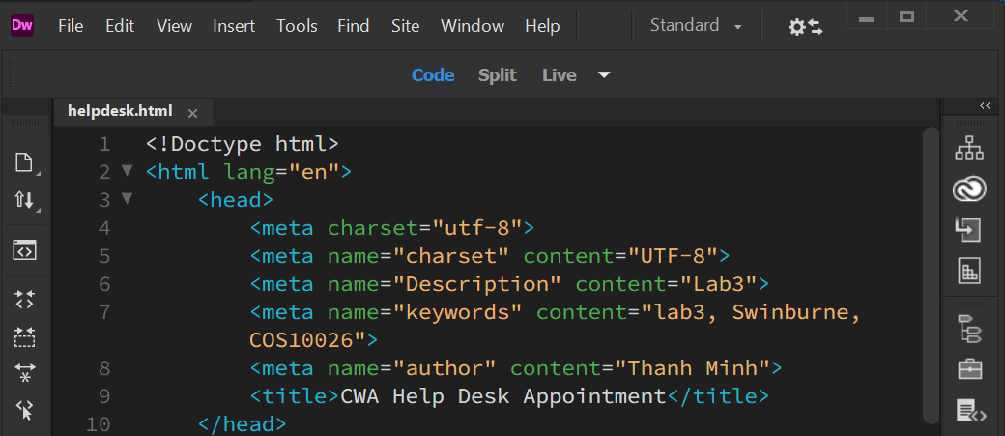

Step 2:

Step 3:

Step 4:

<https://mercury.swin.edu.au/cos10026/s103809048/lab03/helpdesk.html>

Step 5:

